HEMI 2 Model
By Preston Heen
4/6/2020
Introduction
In this lab I wanted to model the one-seed juniper (Juniperus monosperma) using the Hyper Envelope Modelling Interface (HEMI 2). This method is used for modelling habitat suitability of a species. HEMI 2 was made with Monte Carlo methods to be able to perform uncertainty, validation, and sensitivity testing and generates mean and standard deviation habitat suitability maps (Graham 2018). The goal of this lab is to generate a habitat suitability map for one-seed juniper using the HEMI 2 modelling method.
Methods
For this lab I used data for one-seed junipers (Juniperus monosperma), and it has a native range of western North America. This was downloaded from the Forest Inventory Analysis plots. The predictor variables I used were precipitation, solar radiation, and wind. The goal of this lab was to use the HEMI 2 to create a habitat suitability map with injected random noise.
Results
The results of this lab was a map showing the ideal habitat for one-seed junipers, and a map of uncertainty generated from the Monte Carlo.
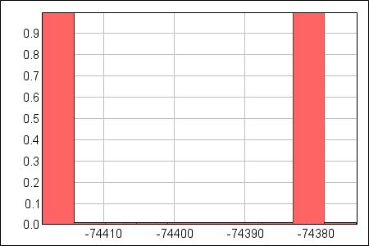
Figure 1. Histogram of all Log Likelihood values
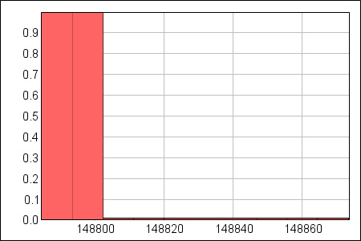
Figure 2. Histogram of all AIC values
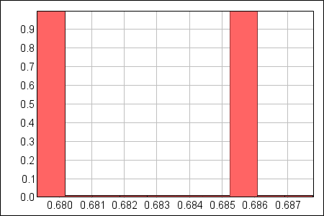
Figure 3. Histogram of all AUC values
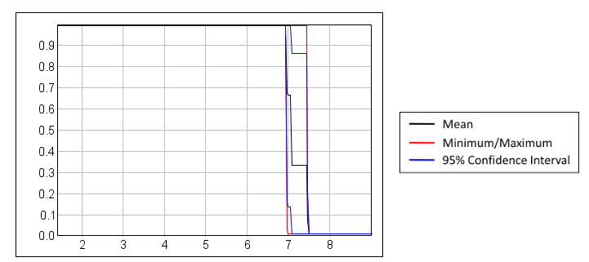
Figure 4. Wind response curve
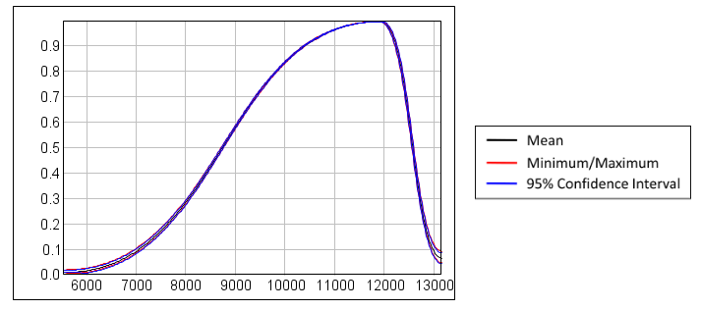
Figure 5. Sun response curve
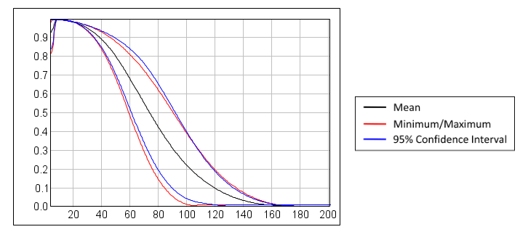
Figure 6. Rain response curve

Table 1. Jacknife results; 0 = wind, 1 = sun, 2 = rain
Covariates in the Model | Mean AIC | Std Dev AIC | Delta AIC | AIC Weight | Mean AUC | Std Dev AUC
0: 0 | 151439 | 80.55 | 2633 | $$2.92*{10}^{-572}$$ | 0.50007 | 0.00003
1: 1 | 149234 | 82.81 | 427 | $$3.10*{10}^{-93}$$ | 0.67073 | 0.00343
2: 2 | 150946 | 44.29 | 2140 | $$2.00*{10}^{-465}$$ | 0.45256 | 0.02567
3: 0, 1 | 149245 | 82.26 | 438 | $$7.70*{10}^{-96}$$ | 0.67082 | 0.00333
4: 0. 2 | 150957 | 44.70 | 2151 | $$1.35*{10}^{-467}$$ | 0.45256 | 0.02567
5: 1, 2 | 148806 | 39.83 | 0 | 0.9933 | 0.68436 | 0.00365
6: 0, 1, 2 | 148817 | 39.72 | 11 | 0,0067 | 0.68437 | 0.00365

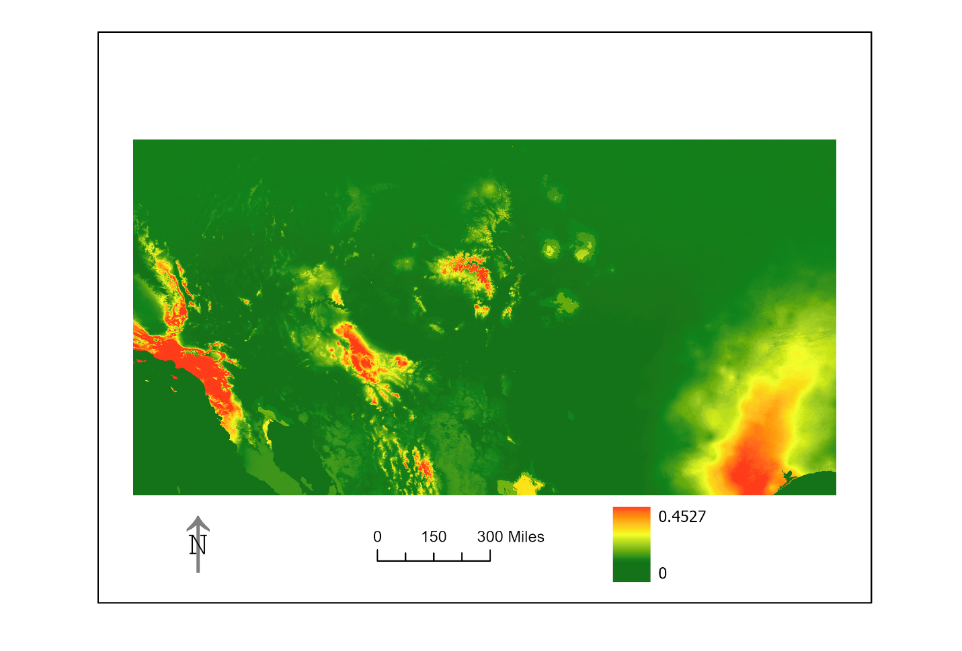Figure 4. Map of uncertainty
Discussion
This model was done with forestry plots as occurrence data, so there was no data outside of a national forest. I am not sure if it is found outside of the southwestern United States. I am uncertain about the wind response curve.
Acknowledgements
I want to thank the Forest Inventory Analysis program for providing the data.
References
Graham, J., & Kimble, M. (2018, December 18). Visualizing uncertainty in habitat suitability models with the hyper‐envelope modeling interface, version 2. Retrieved from https://onlinelibrary.wiley.com/doi/full/10.1002/ece3.4720

